**An initial Assessment of EC campus sustainability**

**By class members of EVS 299:** “Assessing sustainability on the EC campus” (Spring 2011)

**Background**

Eureka College’s core value of Stewardship and Sustainability emphasizes the commitment of the college to managing ***“our resources in ways that preserve both the college and our natural resources for future generations”***. During the Spring semester of 2011, five students participated in a new service learning course, “Assessing Sustainability on the EC Campus”. The students (in alphabetical order), Keelie Carroll, Molly Davis, Wendy Ferguson, Betsy Snobeck, and Carlin Witte, worked with staff and faculty members to gather data about campus sustainability indicators and to provide Eureka College management with a preliminary campus sustainability assessment. David Crady also contributed to this effort through his Senior Seminar Project. Dr. Renée Mullen was the course professor.

**A caveat**

Because this was a one semester class effort by five students with very little experience, readers should keep in mind that this is in no way a comprehensive campus sustainability assessment, but rather a first investigation into what we as a class considered key data. We fully acknowledge that these efforts are in their infancy and hope more than anything that this report provides the impetus to pursue further and more comprehensive assessment, as well as serious consideration to the priority actions recommended.

**General methodology**

Because the list of measurements and ways to evaluate sustainability on a college campus are many, the class researched ways of measuring sustainability and how other college campuses have evaluated their environmental footprints. Numerous colorful discussions led to a series of indicators of sustainability about which we could gather data: **Energy use, solid waste management, water use, dining services, and landscaping, grounds, and building management**. Thanks to numerous staff members, data were obtained for each category. Students then analyzed the data obtained and made recommendations on initial actions the campus community could take to decrease Eureka College’s environmental footprint.

**Summary of findings and recommendations:**

**Energy (Data collected by Betsy Snobeck)**

Electricity: As a campus, we used 3338266.0000 Kilowatt-hours (KWh) or 11390799672 British Thermal Units (Btu’s) of electricity from January 2010 through January 2011 (13 months) (See Figure 1). Our electricity comes from coal combustion and is distributed by Ameren-Cilco. We use about 92 tons of coal per year, equaling about

Natural Gas: We use natural gas at a rate of 226287.5 Therms or 22,600,000,000 Btus for 13 months . Natural gas is used at Eureka College primarily for our heating systems (air and water).

Although these data are not entirely comprehensive (for instance we did not receive electricity usage data from Vennum-Binkley Science Building), the numbers do tell us that **we as a campus use about twice as much energy in the form of natural gas as we do electricity (Fig. 1)**. We can also see that natural gas and electricity usage are different between buildings (Fig 2) even accounting for building size (Fig 3), and between months of the year (Fig 4).

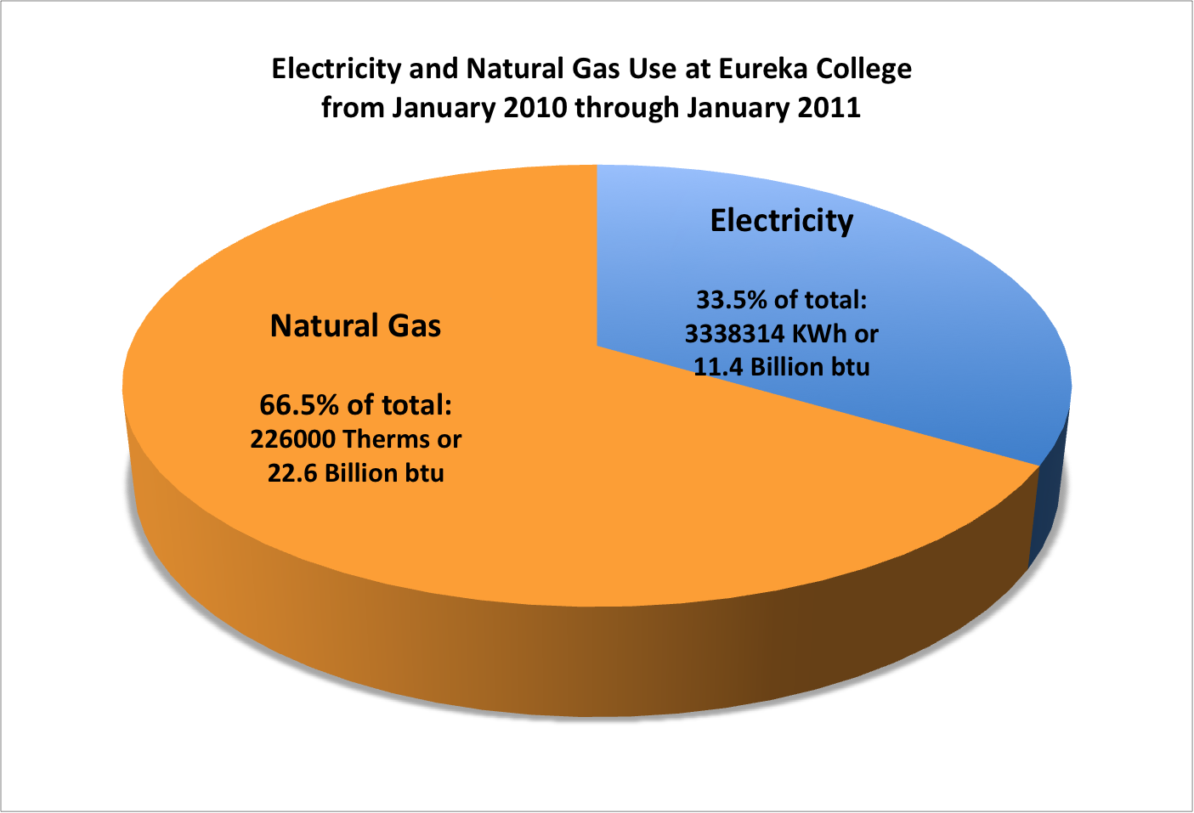

**Fig. 1 Total campus electricity and gas usage from January 2010 through January 2011. In terms of Btus, we used twice as much natural gas (22.6 Billion Btu) as electricity (11.4 Billion Btu).**

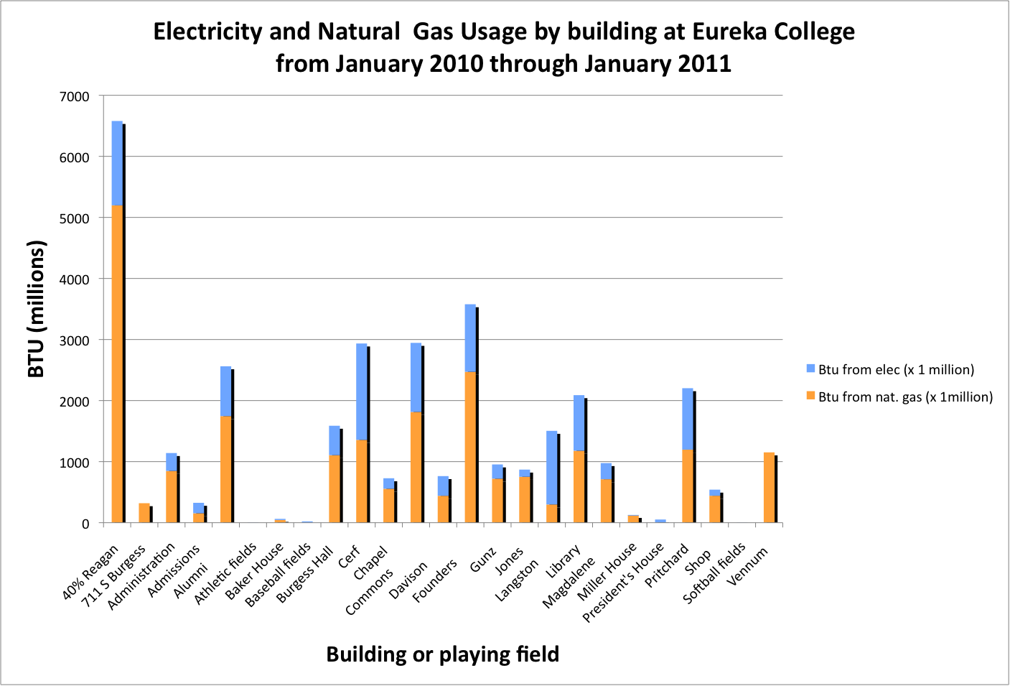

**Fig. 2 Campus electricity and gas usage by building from January 2010 through January 2011. The Reagan Center uses by far the greatest amount of natural gas, whereas the Cerf Center appears to use the most electricity.**

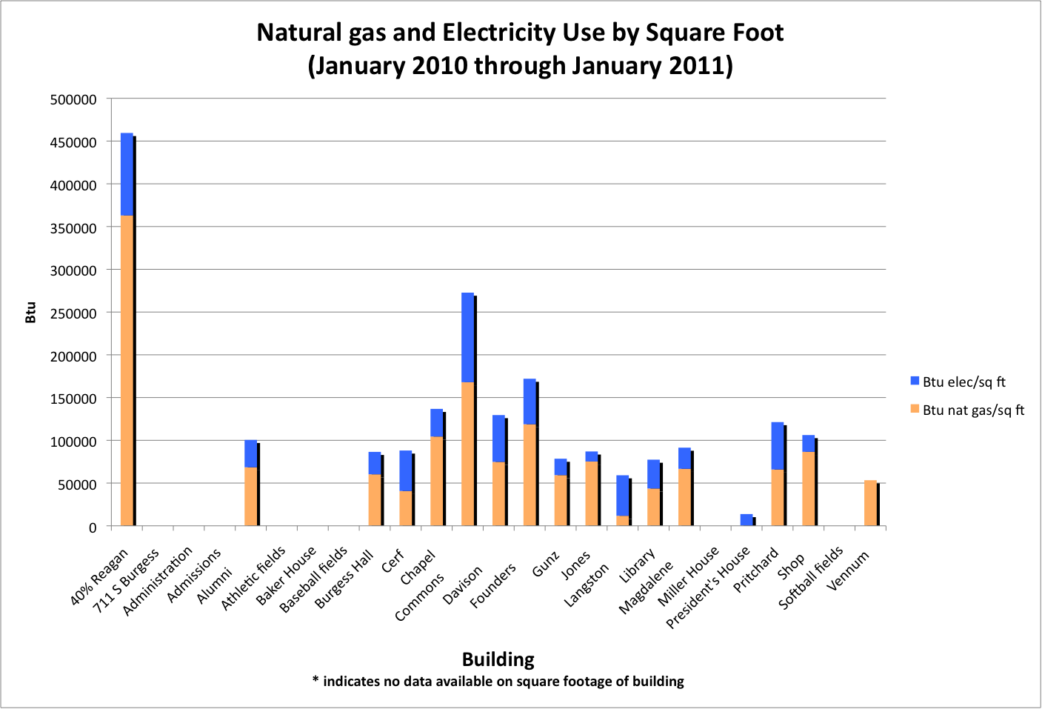

**Fig. 3 Campus electricity and gas usage per building square foot from January 2010 through January 2011. The Reagan Center is the greatest user of natural gas per square foot of building space. When square footage is taken into account, however, the Commons and the dorms are then next in line for the most natural gas usage. When square footage is taken into account, the Commons uses the greatest amount of electricity, followed closely by the Reagan Center.**

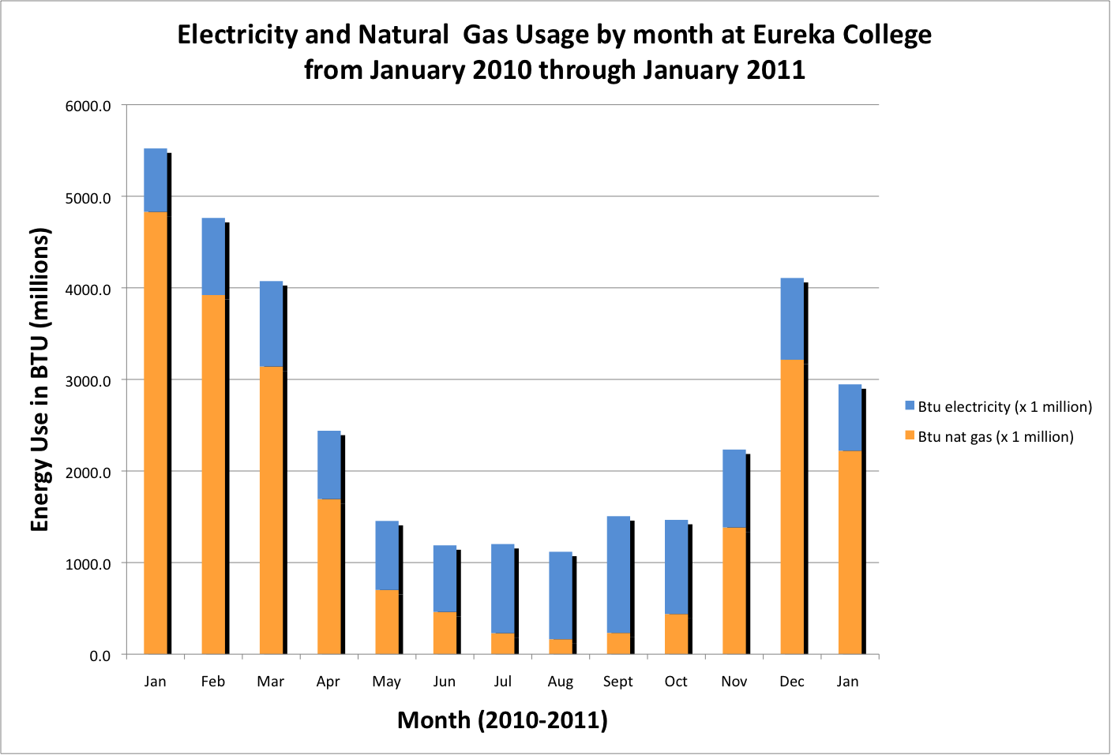

**Fig. 4 Campus electricity and gas usage by month from January 2010 through January 2011. Winter months are associated with the most natural gas use and summer months with the most electricity use.**

**Recommendations:**

Coal and natural gas are fossil fuels – non-renewable natural resources whose extraction and combustion cause pollution (carbon emissions, with coal also emitting sulfur dioxide). Overall recommendations include: 1) **investment in energy sources other than fossil fuels, such as geothermal, wind and solar energy** (Speth 2006). For example, Heartland Community College and Illinois State University have both recently invested in wind towers to supply electricity to their campuses. 2) Install an **Energy Information System (EIS)** that would allow continual and simultaneous monitoring of energy use in all buildings on campus (Motegi et al. 2003). Below are specific recommendations on decreasing natural gas and electricity usage.

**Natural gas use:** Because we use twice as much natural gas as electricity, it makes sense to direct effort toward decreasing natural gas use. One way to do this is to focus on the buildings using the most natural gas per square foot. Although we do not have the square footage data for all the buildings, our data show that the following buildings rank the highest in natural gas usage per square foot: The Reagan Center, The Commons, Founders Court, the Chapel, and the maintenance shop.

Solutions include investing in high efficiency HVAC systems and increasing insulation in buildings to keep heat in and cold out in the winter. The college is already taking steps in the direction of increasing HVAC system efficiency: the new dormitory on campus will have a geothermal heating and cooling system. Thus, a new dorm will be added, but additional energy use and costs for heating and cooling will be low and non-polluting. In addition, Vennum-Binkley is receiving new windows, which were single-paned. It will be interesting to monitor the difference in natural gas usage in the upcoming year.

Additional steps could include: Weatherizing old buildings and keeping thermostats a few degrees lower in the winter (for instance in the commons).

**Electricity use:** Because the burning of coal to produce electricity emits twice the carbon emissions of natural gas per Btu, we must also address electricity use. While electricity use is slightly higher in the summer, it remains relatively constant throughout the year The buildings using the most electricity per square foot are: The Commons, The Reagan Center, Pritchard Hall, The Cerf Center, Langston Hall, Founders Court and Gunz Hall. In lieu of retrofitted geothermal systems for all of our older buildings (which is very expensive, but pays for itself over the long term), increased insulation and weatherizing (to maximize air conditioning efficiency will help tremendously.

There are also a number of different strategies to lessen electricity use, such as replacing old appliances with energy efficient ones, replacing incandescent light bulbs with CFUs, and turning off lights, computers, printers, and other appliances when not in use.

**Water use (Data collected by Keelie Carroll)**

**Background:** Because humans require water to live, clean water is one of our most important resources. Our water at Eureka College comes ultimately from an underground aquifer, locally known as the Sankoty Aquifer (Wilson et al. 1994). The Eureka town water plant accesses the aquifer (or “groundwater”) through two wells located just to the west of Woodford County. These wells were drilled because the surface water Eureka was using from Eureka Lake at the time had become too polluted to use. Unfortunately, groundwater is not unlimited; in other areas further to the west in the Great Plains, aquifers such as the Ogallala Aquifer are being depleted and/or contaminated (Scanlon et al. 2008, Spalding et al. 2003, Peterson et al, 2003).

**Results:** In total, Eureka College used 8,289,600 gallons of purified water from January 2010 through January 2011, with an overall average of 637,611.5 gallons /month. The highest water usage rates were seen in April and September 2010, although months in which students are in session the entire month varied little in water usage. Not surprisingly, higher water usage corresponds with higher campus occupancy.

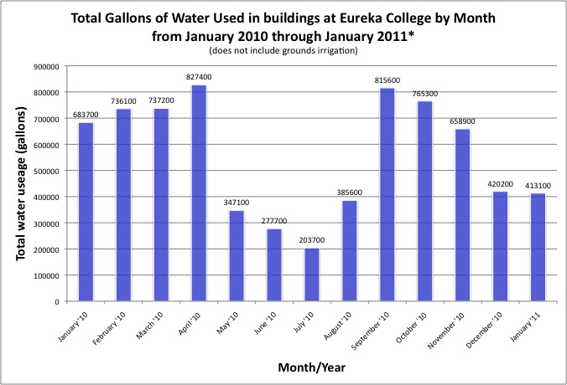

**Fig. 5 Campus water usage by month from January 2010 through January 2011. Peak water usage months are April and September, but it appears that higher water usage months are those in which students are in session the entire month.**

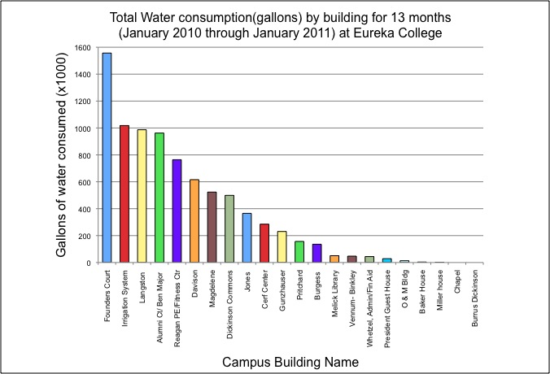

**Fig. 6 Campus water usage by building from January 2010 through January 2011. Founders Court Dorm had by far the highest water usage for the 13 months. The irrigation system and Langston and Ben Major Dorms are all in the running for the second most water used during the time period.**

Most surprising was our finding that Founders Court used the most water (Fig 6). It turns out that Founders Court used 4 times as much water in January 2010 as it did in January 2011. We are not sure what the issue was, but it seems to have been corrected.

Although it is not as surprising that the campus irrigation system ranked second in water consumption for the 13 months, we found it sobering to realize that more than a million gallons (1,018,000 gallons) of purified water were used in only 6 months (May through October).

Purified water usage in buildings at Eureka College varies with the numbers of students and level of activity on campus. The months in which there are the least students on campus correspond to the lowest water use, whereas the months in which students are on campus for the entire month show the highest water use levels. Interestingly, the season/weather does not seem to influence water use very much (Fig. 5).

Recommendations

**Continued monitoring of water use.** Again ,we have no idea what the issue was with Founders Court, but monitoring of water usage (perhaps through a “smart monitoring system”) would allow Physical Plant personnel to address problems promptly.

**Irrigation** was the second highest purified water use for the 13 months. This is water that has been taken from the Eureka Town wells and purified at the water plant. The process of treating water requires costly resources: because the Sankoty groundwater is high in minerals and iron, the water is “softened”, a process which removes iron and minerals. The next step, purification, requires carbon filtering and chemicals such as chlorine. We pay $5.64 for 1000 gallons of water. Yet water used for irrigation does not need to be softened or purified. Many campuses are beginning to reroute their “grey water”. Graywater is untreated household waste water from bathroom sinks, showers, bathtubs, and clothes washing machines. Graywater systems pipe this used water to a storage tank for later outdoor watering use (EPA n.d.) In essence this means using the same water at least twice… resulting in a significant decrease in water usage and thus, cost. Reusing water from showers, sinks, and other non-dangerous sources means also that the college sends less wastewater to the Eureka wastewater treatment plant. That translates to less sewage costs (we pay $3.82/100o gallons of sewage), and even potential savings to the college in terms of town taxes – since these efforts could allow the treatment plant to exist at current capacity longer.

**Water conservation:** When school is in session, our dorms are the buildings with the highest water usage. Water is used in dorms primarily for showering and flushing toilets (and possibly, washing cars and clothes). Fortunately, there are simple and painless solutions for conserving water! For instance, at Luther College, they have installed low-flow shower heads that save at least a gallon per minute of water while showering. <http://www.youtube.com/watch?v=Oec9DPQPAgo&feature=player_embedded> .

Low flow toilets with pressure assist are an easy way to save water. They can save up to five gallons per flush!

We also found significant water usage at the Commons. Although we were unable to determine what most of this water was used for, we suspect a large portion is used for disposing of food. Leftover food in the commons is disposed of by food disposer, which requires significant amounts of water (not to mention adding to our sewage costs. We recommend composting food – which would lessen our water use, would lessen our sewage costs (and the amount of sewage going to the already almost at capacity town sewage treatment plant) and could be used to build nutrient levels in the soil, either for growing food crops or for landscaping.

**Food (data collected by Molly Davis):**

Food is obviously important to us all. Unfortunately, food production and consumption can contribute greatly to our environmental footprint. Our food is imported and transported, using fossil fuels. Our food is grown with chemical fertilizers and pesticides – not only using more fossil fuels, but also polluting our soils, water, and atmosphere. When we are done with our food, the packaging goes in the trash (landfill) and the leftover food goes into the trash or, as in the case of Eureka College, down the food disposal, out the sewer lines, to the waste treatment plant.

Our food at Eureka College is supplied by Sodexo, so that choices for our foods are somewhat limited. We decided in this study to focus on food waste (as mentioned above).

For two weeks, Commons staff members weighed food disposed of by students. The average amount of food thrown away in one week was 731.5 pounds… So 23300 pounds or 11 tons of food is thrown away (put into the food disposer with water) every school year.

One ton is about what a large cow weighs.

X 11 (food thrown out per year at EC)



Eureka College has already implemented a “trayless” policy, so that students take what they can carry without using a tray. It has been shown that this in itself produces large food waste savings. But we are still throwing away 11 tons of food a year! In other words, all that fuel for transportation of food, all those packages, boxes, bags, and wrappings that food comes in, all those pesticides, hormones, and fertilizers in our foods .. are used just to throw a large percentage of the food away (which again, uses water to enter the sewage stream and must be dealt with by the town of Eureka at the waste treatment plant).

Recommendations:

* Buy local and organic food: Local food would not have to travel as far and would require less fossil fuel to be used. Organic food or food grown without chemicals use less fossil fuels and do not pollute water and soil with chemical fertilizers and pesticides. They also require much less processing and packaging (again adding to the waste stream)
* Compost! Left over food could be composted (as is currently being done at Illinois Wesleyan and many other schools), instead of sent down the food disposer with extra water.
* Grow our own vegetables! A number of colleges and universities are establishing their own farms and gardens – and are able to use their food and landscape wastes to fertilize and build soils for healthy crops. Students can learn about plants, soils, and crops while providing vegetables (for example) to the dining facilities. Whereas it is difficult for Sodexo to buy and distribute locally grown food, it does have a provision for serving food from a campus’s own garden.

**Grounds and Buildings (data collected by Wendy Ferguson)**

Landscaping:

Sustainable landscaping should include: plantings native to the area, minimized water consumption and run-off, reuse of organic waste and the health and well being of the individuals within the landscape. Sustainable landscapes on a college campus can also provide for the education of its students as well as the community as a whole.

We decided to focus on two main components of landscaping: 1) Percent of impervious surfaces (like asphalt, concrete, rooftops, etc.; surfaces that do not let water through) vs. pervious surfaces (like gardens, lawn, woods, etc.) and 2) types of landscaping and plants used on campus.

**Impervious surfaces** cause rain and irrigation water to run off into the nearby creeks, bringing with it any pollutants (oil, gas, pesticides, fertilizers, etc.) on the impervious surfaces.

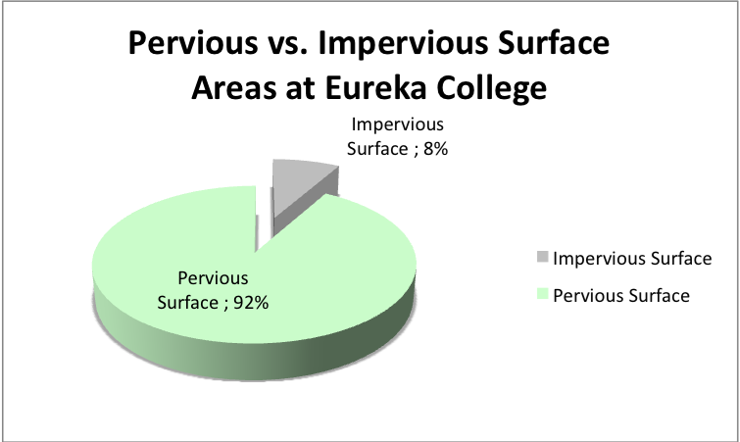

**Fig. 7**

Eureka College has only 8% impervious surface, which is very low compared with many campuses, especially those in urban areas (Fig 7). However, even 8% impervious surface leads to a total amount of 9 million cubic feet of water runoff from the campus.

*Recommendations:* If we could utilize even a small portion of this water to offset that which we use for irrigation (1 million gallons of water per year to water the athletic fields and grounds, at a cost of almost $600.00 per year), we would both be saving money and water. The amount of runoff that could be collected from the roofs of the buildings alone is over 3.3 million gallons.

**Landscaping.** During interviews with Mr. Westfall and staff members it was discovered the college currently does not have a specific planting plan in place. Large areas of traditional turf lawn require a staff member to mow almost eight hours a day, five days a week throughout the growing season. Currently, there is no compost program in place to deal with the waste produced by pruning, raking and general maintenance of the grounds. Chemicals such as 2,4-D are used to reduce the amount of weeds on campus, in particular, dandelions.

There are, however, several examples of positive steps being taken toward sustainability. The flowerbed by Pritchard Theater, currently planted in Echinacea, purple coneflowers (Fig 8), is an excellent example of using native plants. Other areas include the flowerbed in front of Melick Library with native bluebells (Fig 8), the naturalization of Spring Beauty plants in the area between the Cerf Center and Pritchard parking lot, and the use of native trees on campus. Of course, one of the highlights is the Prairie Restoration Area, an area of native grasses and flowers that would have been found in this area at the time of the first settlers. These steps toward sustainable landscapes are to be commended.

*Recommendations:* The benefits of native plants are many. Native plants are well adapted to their environment. This means less mowing, so less fossil fuels being used. In addition, irrigation, pesticides and fertilizers are not needed, ultimately lowering maintenance costs. Over a ten year period the cost difference between traditional lawn maintenance and installing native plant gardens can be as high as $50,000 (Fig 9). It seems an obvious solution with benefits on both sides of the equation. Cost wise it is cheaper and environment side it is healthier and more sustainable.

**Fig. 8 Purple Coneflower Bed by Pritchard Theater and the bluebells in front of Melick Library, photos by W. Ferguson 2011**

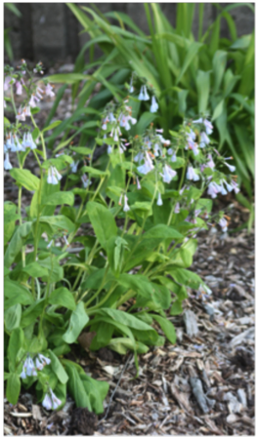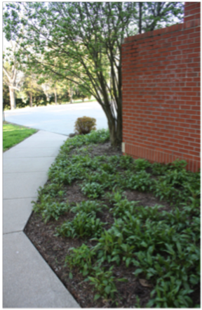



**Fig 9** shows the cost comparison between native plants and traditional turf landscape over a ten year period.

**Building Maintenance and Cleaning (data collected by Wendy Ferguson)**

We were unable to quantify amounts of types of cleaning compounds and paper products used in our buildings on campus. We did find out that many of the products used for cleaning are “green products” supplied through Sodexo, although we were unable to find out much about these products. We were unable to determine the extent to which paper towels and toilet paper are made from recycled material. This will be important to explore.

We were also unable to determine the kinds of pesticides used in the Eureka College Buildings. Building pest control is contracted out to American Pest Control <https://callamericanpest.info/inner/green_pest_control.htm>

The company does not list the types of chemicals it uses on its website. It does mention that the focus is on prevention using methods not requiring chemicals. However we have only observed the contractor spraying chemicals in and around the buildings at Eureka College.

*Recommendations:* We recommend that supplies used for cleaning and maintenance (both contents and quantity) be more closely monitored and documented over time. In addition, it would be helpful to keep track of the types of pesticides used by the American Pest Control contractor. There are a number of pesticides toxic to humans. Three recent studies found that children born to mothers exposed to organophosphate pesticides had significant decreases in IQ when compared with children of mothers not exposed (Gray and Lawler 2011).

**Solid Waste (data collected by dumpster divers and Carlin Witte)**

The US continues to need more and bigger landfills to dispose of solid waste, both industrial and municipal (city) waste (US EPA 2010).

Our solid waste is shipped by Eureka Disposal Company to the Indian Creek Landfill, near Hopedale, IL, owned by Peoria Disposal Company (about 1 hour from here). We were unable to obtain data on how much solid waste Eureka College generates, because the amount is not quantified by Eureka Disposal or Peoria Disposal. We do know that we have 14 solid waste “dumpsters” on campus. A “dumpster dive” was held on April 27, 2011, to determine the amount of waste in one dumpster (the dumpster on the east side of the Cerf Center, near the Burgoo). Students, faculty, and staff emptied the entire contents of the dumpster and separated the contents into recyclable, compostable, and neither recyclable nor compostable items (Fig 10). Keep in mind that all of this material was headed to the landfill before we separated the recyclable and compostable components.

**Fig 10:** Eureka College Dumpster was full of 260 lbs of waste. 90% of the contents were recyclable or compostable, yet it was on its way to the landfill

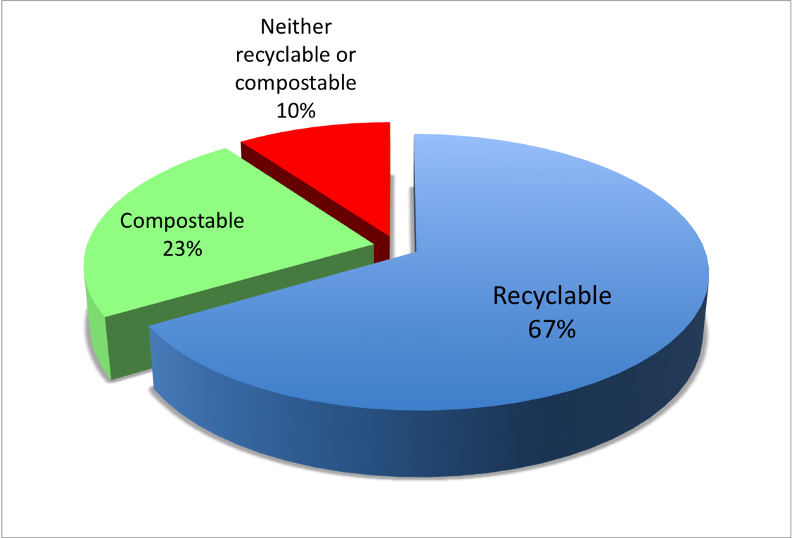

*Results of dumpster dive:* We learned that out of 260 pounds of “trash”, 173 pounds were recyclable by our campus recycling facility, 61 pounds were compostable, and only 26 out of the 260 pounds (or 10%) needed to go to the landfill. In other words, 90% of the materials in the dumpster were recyclable and compostable. Yet all these materials were headed to the landfill. Given the effort and admittedly, the “ick factor” of dumpster “diving”, we can assume that dumpsters do not regularly undergo such scrutiny. Therefore we can assume that every 2 days during the school year, on the average, 260 pounds (or thereabouts) of solid waste per dumpster or 2640 pounds (14 dumpsters x 260 lbs/dumpster) of trash is trucked to the landfill while school is in session. So if we say 2640 x 3 to make 1 week = 10,920 lbs of trash per week x 32 weeks per year = 349,440 pounds of trash per year (not counting summer). Of that 349,440 pounds of trash approximately 234,125 lbs. could be recycled, while 80,371 pounds could be turned into valuable compost, leaving 35,000 lbs instead of 350,000 lbs going into the landfill.

Right now – we are recycling an average of 467 pounds of material per week (data from Eagle Enterprises 2011). So 467 +10,920 = 11387 lbs of solid waste generated per week. The amount we are currently recycling of our total waste is thus 4.1%

The American public is doing much better than that, even though most communities do not have single stream recycling (you can throw everything into one bin) like we do. The percent municipal solid waste recycled in the US in 2009 was 25% with 9% being composted, 12% being combusted for energy, and 54% going to the landfill (Fig 11 created with data from EPA 2010).

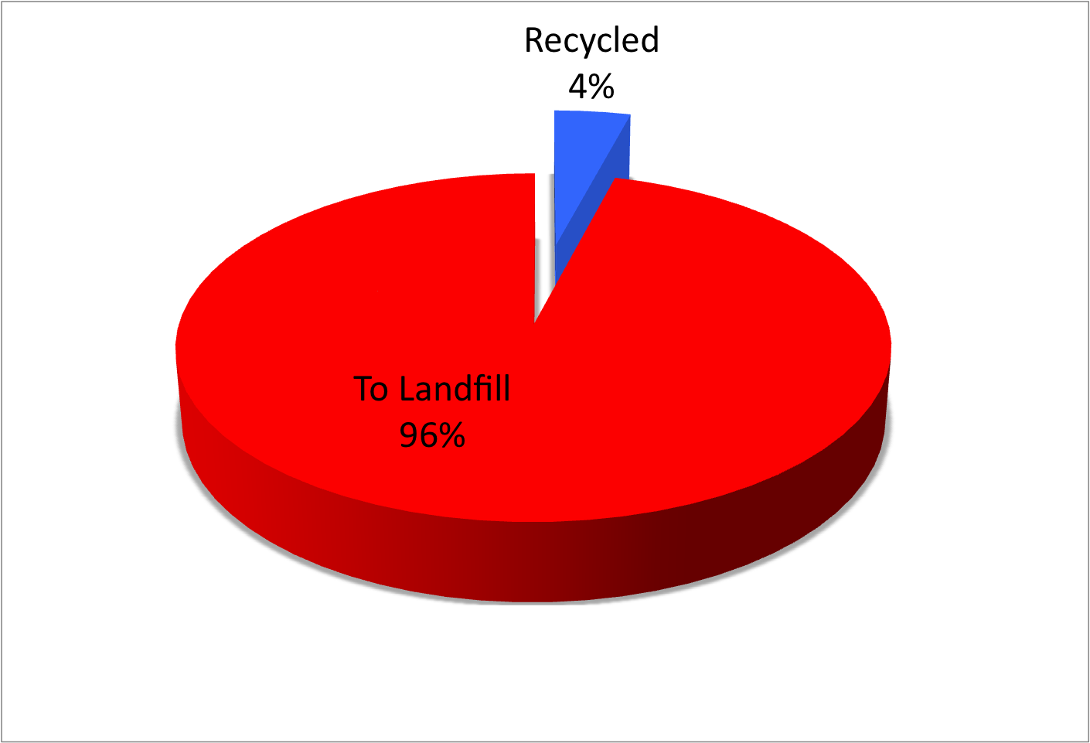

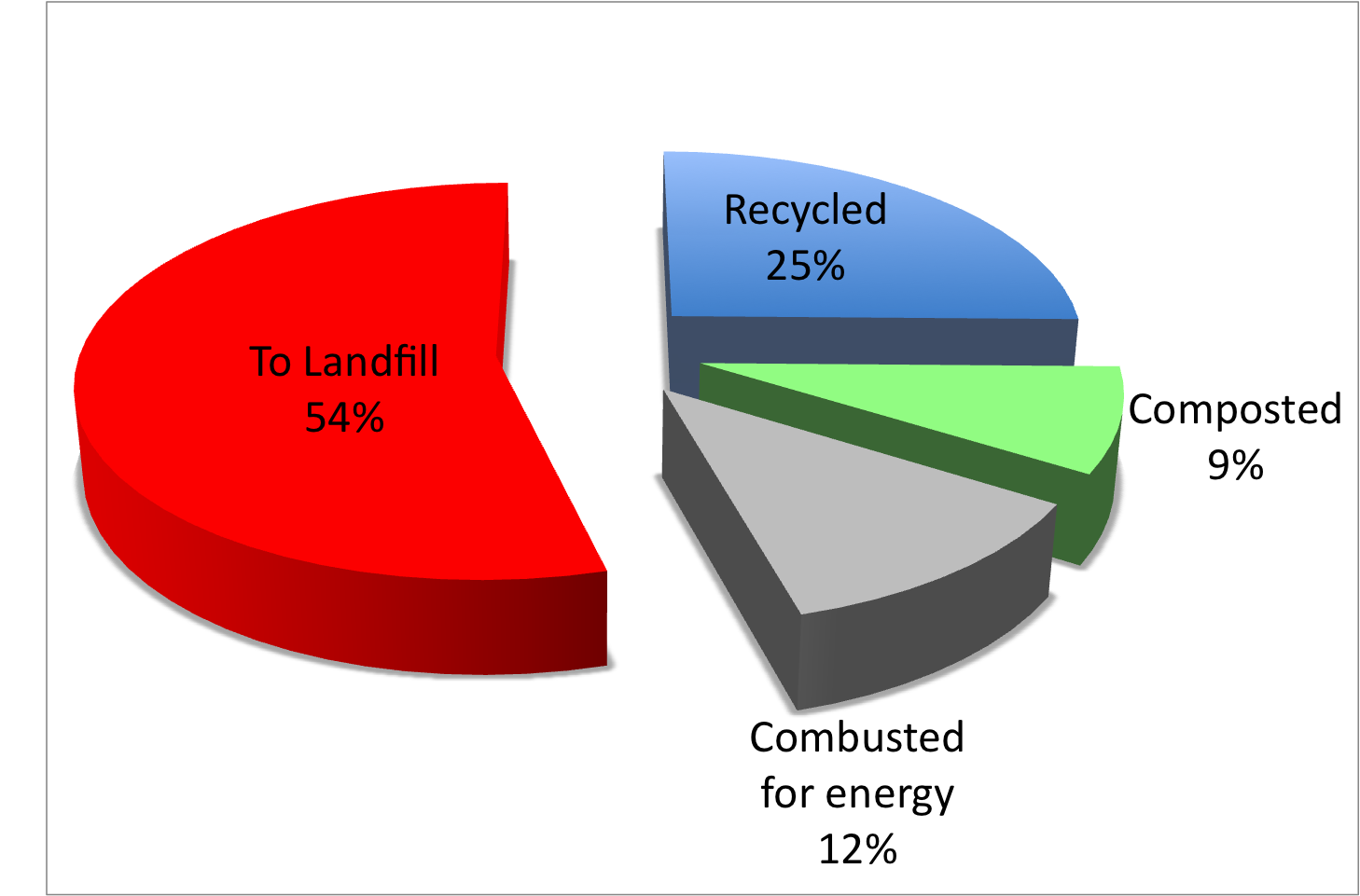

1. US Solid Waste 2009 (EPA.gov 2009)

b. Eureka College Solid Waste 2010 (Witte 2011)

**Figure 11**

Recommendations:

Our data clearly show that more solid waste could be recycled at Eureka College. There is not much financial incentive to do so, however. Eureka Disposal does not charge us as much to pick up and transport our waste to the PDC landfill as Eagle Enterprises does to pick up our recyclables. This seems strange because some money can usually be gained by selling solid waste that can be recycled (like aluminum cans), but it appears that Eagle Enterprises must transport our recycling so far, that this (along with a saturated market) virtually cancels out the worth of the materials to be recycled. We are unsure how to recommend a solution to this problem.

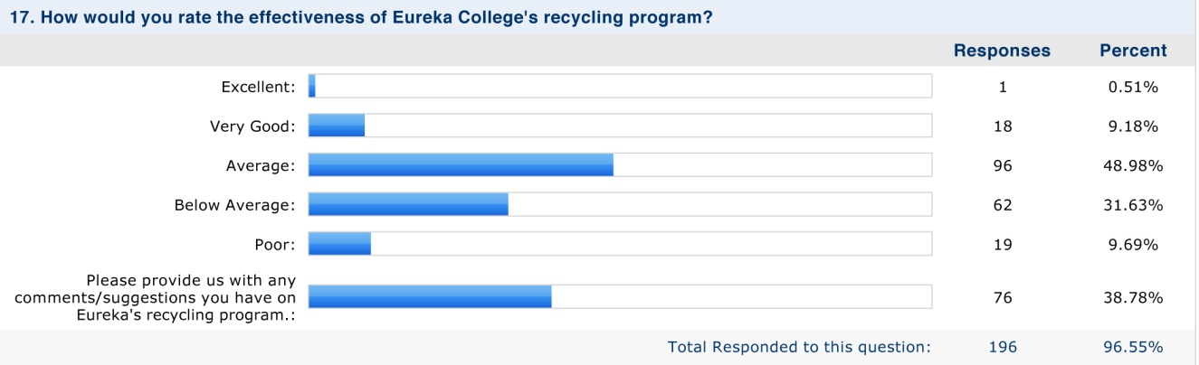In terms of behavior of students, faculty, and staff, we turn to the sustainability survey that David Crady used to gauge attitudes toward sustainability measures (entire survey can be found in the appendix). Students were asked to rank the recycling program at Eureka College and to make suggestions. 80% of students rated the recycling program as average or below average (figure 12).

81 survey respondents suggested ideas for increasing recycling at EC. The primary issue for respondents was the number and placement of recycle bins and the frequency with which they are emptied (see appendix). Such actions would go far to increase the level at which the college recycles and would decrease the amount of solid waste traveling to the landfill. But is there a way to make this economically beneficial at the same time?

Additional survey responses support increased sustainability efforts on the EC campus:

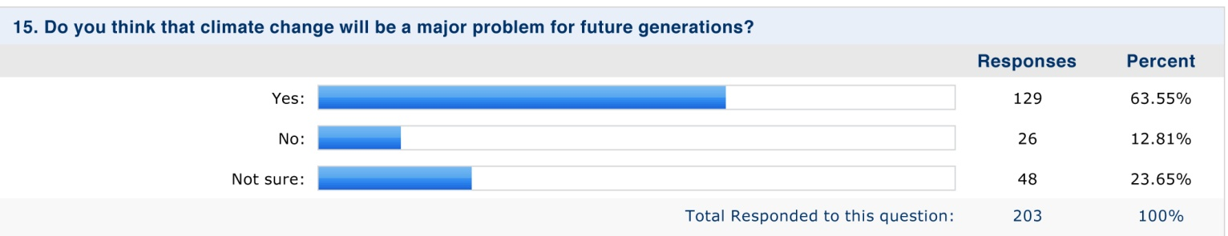

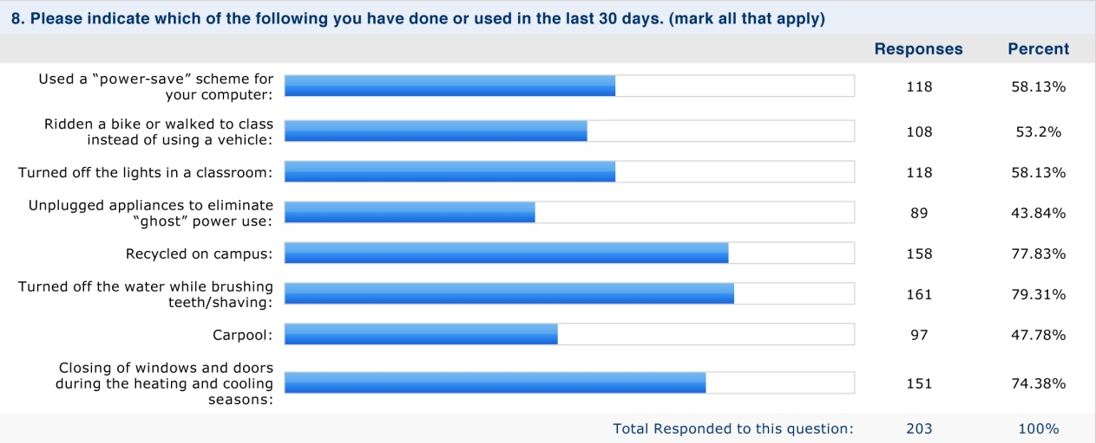

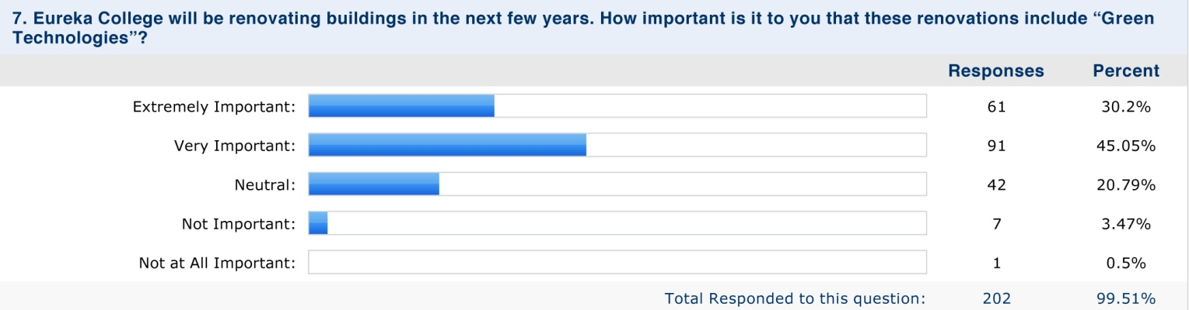

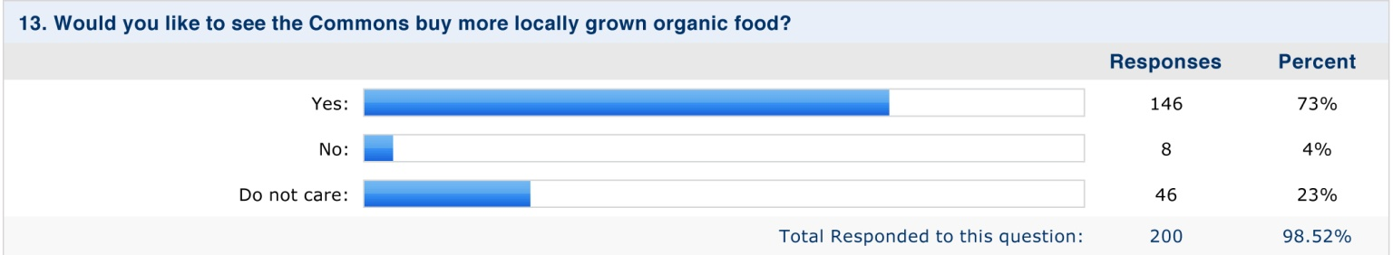

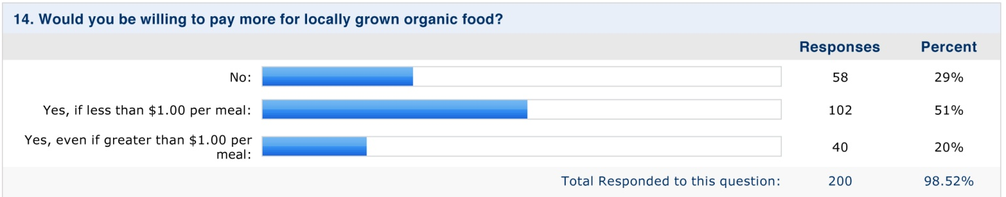

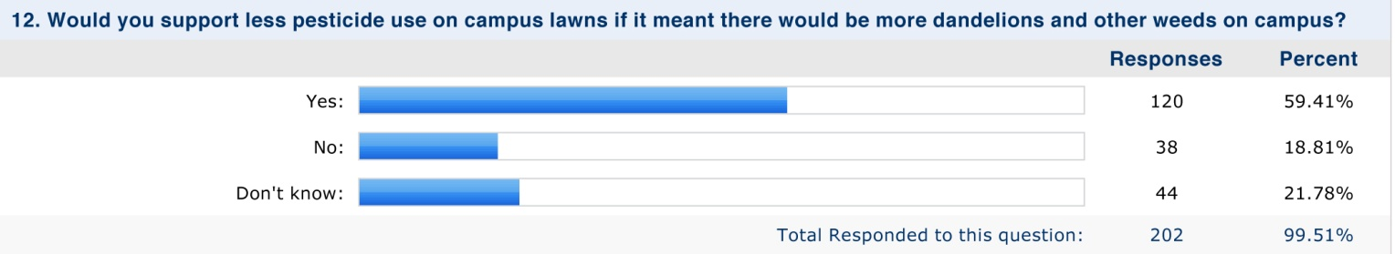

Conclusion:

Acknowledgements

Figure 12

**References**

Gray K, Lawler CP 2011. Strength in Numbers: Three Separate Studies Link in Utero Organophosphate Pesticide Exposure and Cognitive Development. Environ Health Perspect 119:a328-a329. doi:10.1289/ehp.1104137

Hong, BD and Slatick, ER (1994) Carbon Dioxide Emission Factors for Coal  Energy Information Administration, *Quarterly Coal Report, January-April 1994: 1-8*, DOE/EIA-0121(94/Q1) (Washington, DC) **retrieved 8-10-11 from** http://205.254.135.24/cneaf/coal/quarterly/co2_article/co2.html

*Motegi, Naoya, Piette, Mary Ann; Kinne, Satkartar, Dewey, Jim, 2003* Case Studies of Energy Information Systems and Related Technology:Operational Practices, Costs, and Benefits . *International Conference for Enhanced Building Operations. http://energy.ucsb.edu/_client/pdf/news/LBNLCaseStudy.pdf*

Peterson et al, 2003

Scanlon et al. 2008

Statistics Analysis Service, *Compendium of Agricultural-Environmental Indicators 1989–91 to 2000* (Rome, November 2003), p. 11.

Spalding et al. 2003

USEPA. 2010. Municipal Solid Waste in the United States. Retrieved 8-10-11 from <http://www.epa.gov/osw/nonhaz/municipal/pubs/msw2009rpt.pdf>

USEPA: Water Efficient Landscaping: Preventing Pollution and using resources wisely. (no date) Retrieved 8-12-11 from <http://www.epa.gov/WaterSense/docs/water-efficient_landscaping_508.pdf>

Wilson SD, Kemtpton JP, Lott RB. 1994. The Sankoty-Mahomet Aquifer in the Confluence Area of the Mackinaw and the Mahomet Bedrock Valleys, Central Illinois. Cooperative Groundwater Report (Illinois Department of Energy and Natural Resources) Retrieved 8-10-11 from http://www.isws.illinois.edu/pubdoc/COOP/ISWSCOOP-16.pdfUnited Nations Food and Agricultural